

**School of Computer Engineering**

**SCE11-0353**

**WEB APPLICATION FOR RADIOLOGY INFORMATION SYSTEM**

Submitted in Fulfillment of the Requirements for the

Degree of Bachelor of Computer Engineering of the

Nanyang Technological University

Author: Desmond Poh Lik Meng (U0922923K)

Supervisor: Assoc Prof Lin Feng

2012

# Abstract

Telemedicine is emerging as a fast growing medical technology in the health care industry. It helps to eliminate distance barriers and can improve access to medical services that would often not be usually available in distant rural communities. Created from a convergence of telecommunication and information technologies, telemedicine permits communications between the patient and healthcare provider with fidelity and convenience.

The most popular use of telemedicine is via teleradiology, which is the ability to send medical images from one location to another. Traditionally, it requires a sending station, a receiving station, and a transmission network. However, with today’s high-speed broadband Internet, healthcare professionals and patients alike can view medical images stored on remote servers; only a standard Personal Computer and DSL/Cable Internet connection is needed.

In this project, we will be developing a web based Radiology Information System (RIS), in an attempt to migrate the information systems used in radiology departments online. It aims to let healthcare professionals access patient medical data at any time, while letting patients themselves monitor their health.

The development process, from its inspiration to implementation to wrap up, is documented in this report. Special attention is given to discussing the application design, difficulties encountered during design and development, the strengths and weaknesses of the application, and areas that can be improved upon in future.

// TODO: Resummarize this report after finish the entire project

Acknowledgement  
I would like to express my deepest gratitude to the following individuals who have provided me valuable insights, help and guidance for completing my Final Year Project.

* Dr. Lin Feng, my project supervisor. His guidance and encouragement has proved invaluable at all stages of this project. Were it not for him, this project would not have even be half completed.
* The staff members at the Radiology Department of Raffles Medical Group. Their paid introductory tour of a typical workflow process of their department gave many insights into the potential challenges this project would be facing.
* The team at BitBucket, a source version control vendor. Their graciousness to upgrade the code repository at no cost meant that critical mistakes made during development can be rolled back without any down time.
* All my friends and family who have supported and helped me during the time which this project was going through a difficult development period.

# Table of Contents

Abstract ii

Acknowledgement iii

Table of Contents iv

List of Figures v

List of Tables vii

1 Introduction 1

1.1 Background 1

1.2 Objective 2

1.3 Scope 3

1.4 Project Planning and Schedule 4

1.5 Resources 6

1.6 Report Organization 7

2 Literature Review 8

2.1 Radiology Business Model 8

2.2 ASP.NET 11

2.2 C# 12

2.3 Microsoft SQL Server 2008 R2 12

2.4 DICOM 13

2.5 DICOM Frameworks 15

3 Database System Design 16

3.1 Overview 16

3.2 ASP.NET Tables 18

3.3 Radiology Information System (RIS) Tables 24

4 Web Application Modules 30

4.1 Overall Application Design 30

4.2 Data Access Layer 32

4.3 Application Logic Layer 34

4.4 View Layer 35

4.5 Physical Organization 36

5 Experimental Systems and Results 39

5.1 All Users 39

5.2 Admin 44

5.3 Physician 45

5.4 Radiologist 47

6 Discussion and Conclusion 48

6.1 Summary 48

6.2 Discussion 48

6.3 Future Work 49

References 50

Appendix 51

# List of Figures

Figure 1 – Original Schedule 4

Figure 2 – Actual Schedule 5

Figure 3 – Outpatient Process 8

Figure 4 – Inpatient Process 9

Figure 5 – Radiology to DICOM 10

Figure 6 – Sample DICOM File 14

Figure 7 – All Database Tables 17

Figure 8 – aspnet_Applications 18

Figure 9 – aspnet_Membership 19

Figure 10 – aspnet_Paths 19

Figure 11 – aspnet_PersonalizationAllUsers 20

Figure 12 – aspnet_PersonalizationPerUser 20

Figure 13 – aspnet_Profile 20

Figure 14 – aspnet_Roles 20

Figure 15 – aspnet_SchemaVersions 21

Figure 16 – aspnet_Users 21

Figure 17 – aspnet_UsersInRoles 21

Figure 18 – aspnet_WebEvent_Events 22

Figure 19 – Membership Configuration 23

Figure 20 – Appointments 24

Figure 21 - BloodTypes 24

Figure 22 - Countries 24

Figure 23 - Departments 25

Figure 24 - DicomImages 25

Figure 25 - DrugAllergies 25

Figure 26 - Images 26

Figure 27 - Modalities 26

Figure 28 - Patients 27

Figure 29 – PatientsWithDrugAllergies 27

Figure 30 – Series 27

Figure 31 – Staff 28

Figure 32 - Studies 28

Figure 33 - UserParticulars 29

Figure 34 – Overall Design 30

Figure 35 – Section of LINQ Classes 33

Figure 36 – Folder Layout 36

Figure 37 – Main Page 39

Figure 38 – Log In 39

Figure 39 – Create New Account (Patient) 40

Figure 40 – Change Password 40

Figure 41 – Change Reset Question 41

Figure 42 – Update Particulars 41

Figure 43 – About 42

Figure 44 – Reset Password 42

Figure 45 – Error 43

Figure 46 – Add User 44

Figure 47 – Manage User Roles 44

Figure 48 – New Imaging Order 45

Figure 49 – Update Patient Blood Type 45

Figure 50 – Add Medical Allergy 46

Figure 51 – Start New Series 47

Figure 52 – Upload DICOM 47

Figure 53 - Database Schema 52

# List of Tables

# Introduction

## **Background**

Telemedicine refers to provision of medical information and services via telecommunication devices. Created from a convergence of telecommunication and information technologies, it not only permits long distance communication between healthcare providers, but also with patients, via today’s broadband Internet infrastructure.

Telemedicine is part of a larger movement towards electronic based healthcare (eHealth). Compared to traditional healthcare, the concept of eHealth is based upon the central idea of storing all medical information, records and images electronically. Although adoption of eHealth varies widely, both internationally and within Singapore itself, most medical institutions have already migrated much of their paper-based processes to Healthcare Information Systems (HIS).

Complementing a HIS is a specialized subsystem called Radiology Information System (RIS). As its name implies, a RIS is used almost exclusively by the radiology department of a medical institution. In layman’s terms, a RIS is a computerized database for storing, manipulating and distributing patient radiological data and imagery.

## Objective

The objectives of this project are as follows:

* To allow radiologists to work using the RIS system, and its underlying database
* To allow radiologists to retrieve imaging orders for a patient referred to them
* To allow radiologists to store medical image(s) taken
* To allow radiologists to enter data relating to the medical image
* To access the Outpatient Information System (OPIS) database, which is being developed concurrently in another project, in future

## Scope

The scope of this project is as follows:

* Visit a radiology department of any medical institution to gather as much information as possible on the workflow process
* Understand the commonly used technical jargons in radiology
* Analyze the requirements of the RIS based upon information gathered
* Learn and understand DICOM, the standard used in medical imaging
* Learn ASP.NET, the web technology upon which the RIS will be hosted on
* Learn C#, the primary programming language that will be used in this project
* Learn SQL Server 2008 R2, the database that will be used in this project
* Design and develop the backend database iteratively
* Design and develop the RIS web application iteratively
* Learn about technologies that might potentially shorten the development time of the RIS and utilize them, if possible
* Explore about the possibility of optimizing the RIS for mobile platforms, if time permits

The fully implemented RIS shall fulfill the objectives of this project, as stated in section 1.2.

## Project Planning and Schedule

The initial proposed project schedule is indicated in Figure 1. As the project goes into the implementation stage, it is expected that difficulties will force a rescheduling of the development flow.

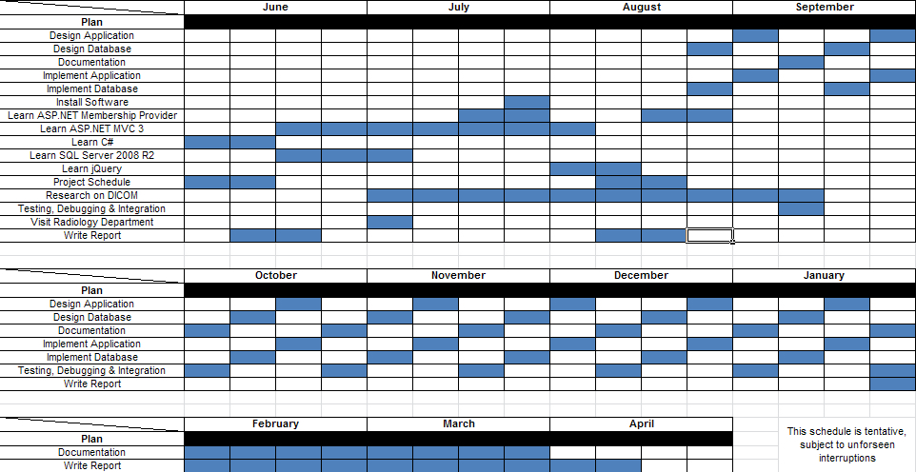

Figure 1 – Original Schedule

Figure 2 shows the actual development that took place, due to the expected difficulties that were predicted during initial planning.

Notice that development activity became unusually heavy since the second week of December. This was due to discovering that NHibernate, a critical software framework for abstracting interactions with the underlying Microsoft SQL Server 2008 R2, was deemed to be incompatible with a new feature of the database very late during development.

As such, all work that was done up to that point had to be abandoned, and the project essentially restarted from scratch. Moreover, the DICOM standard specifications are still posing a challenge at the time of writing, thereby necessitating more research activity on it until the last iteration of development.

Thankfully, despite the restarting of development work, the database schema was able to be reused due to a conscious effort from the beginning to separate the data persistence and application logic layers.

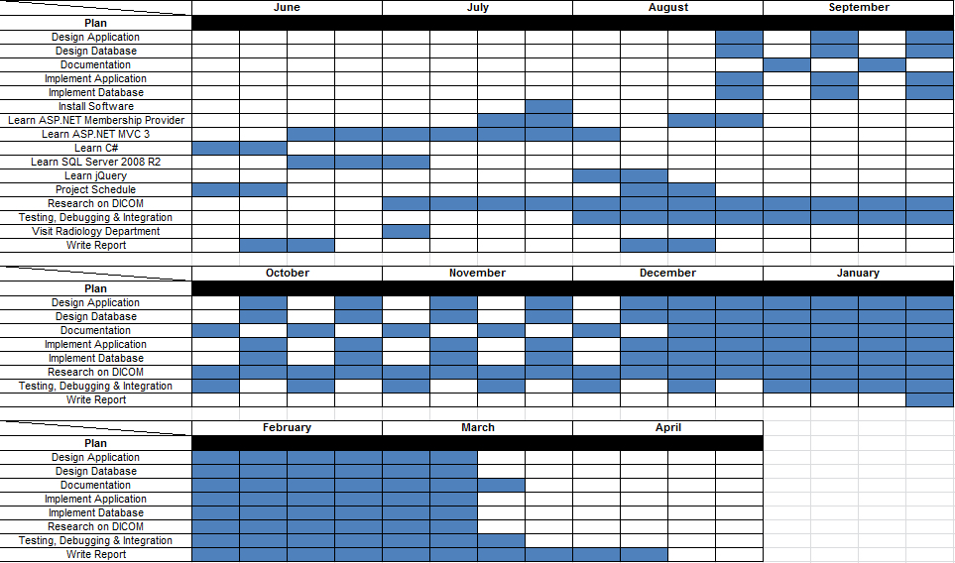

Figure 2 – Actual Schedule

## Resources

Two specific software suites were utilized in the design and development of RIS:

* Microsoft SQL Server 2008 R2
* Microsoft Visual Studio 2010 Ultimate

In addition to design and development, this project also utilized other software as follows:

* AJAX Control Toolkit. An AJAX UI framework built on top of the default ASP.NET AJAX controls
* ASP.NET. A web application framework from Microsoft to build dynamic web applications
* dotPeek. A .NET decompiler
* Git. A revision control managing the changes to program files, database files, documentation etc.
* Microsoft Office. A productivity suite for formally documenting the development process in the form of a report
* NuGet. A package manager for the .NET Framework
* ReSharper. A productivity extension to Visual Studio that helps to maintain and improve C# code (among many others) in Visual Studio projects.

## Report Organization

This report is organized in the following manner:

**Chapter 1** presents an introduction the reader regarding the project. It includes the background information to help readers understand the objectives of the project.

**Chapter 2** presents an explanation of the business and working model of a sample radiology department. It gives a sample radiology workflow and layman explanations of jargons. A literature review of DICOM, C#, Microsoft SQL Server 2008 R2 and aspects of ASP.NET that were utilized is also given.

**Chapter 3** presents the database system design that is used in the web application. It provides the specifics of the schema of the database and provides the rationale for the choices made, where applicable.

**Chapter 4** gets into the technical implementation of the web application. The server and client side designs are elaborated upon in this section. It provides the rationale and advantages of critical design decisions.

**Chapter 5** presents the experimental system and results. Details will be given on the rationale behind implementation. Where appropriate, screenshots will be provided.

**Chapter 6** concludes the project and includes discussions on possible future development and enhancements.

# Literature Review

## Radiology Business Model

To better understand the workflow processes and jargons used within a radiology department, a paid, introductory tour was arranged with Raffles Medical Group. The tour occurred during the first week of July 2011.

According to the medical center, a typical process for outpatients would be as shown in Figure 3, whereas a typical process for inpatients would be as shown in Figure 4.

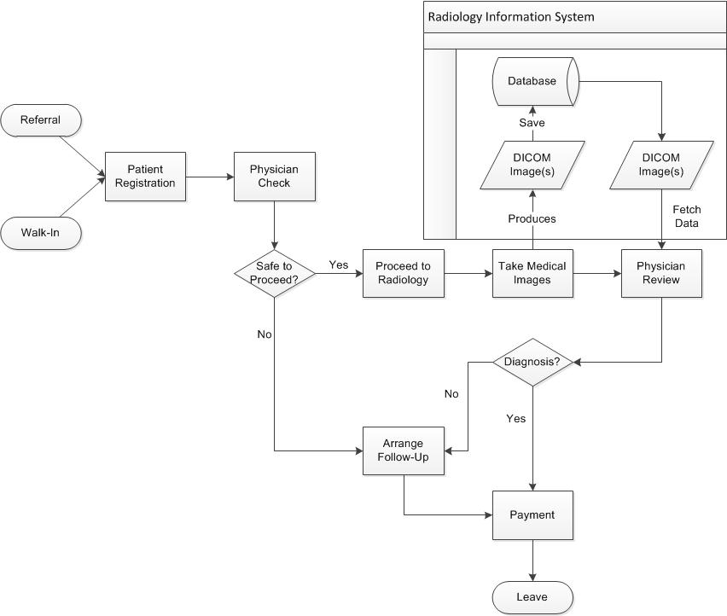

Figure 3 – Outpatient Process

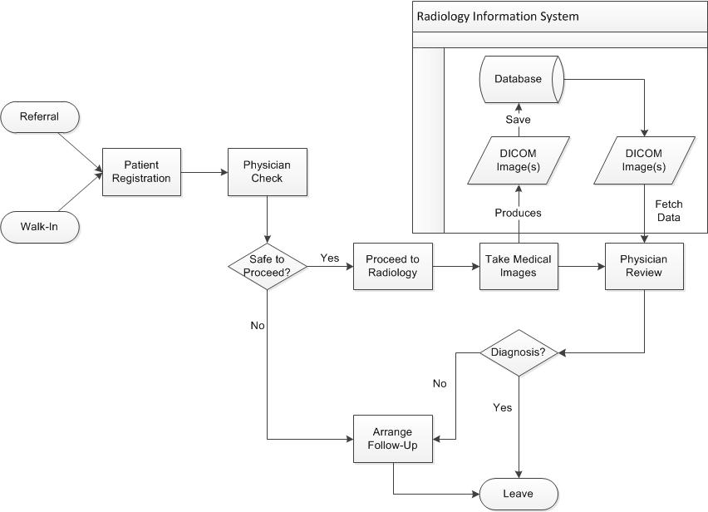

Figure 4 – Inpatient Process

For both processes, we see that the RIS is only used during the saving and retrieving of medical images.

When a patient is referred to the radiology department, s/he has started a study. In a study, different types of imaging equipment (series) might be used. Each series represents a different modality, and can have several images. This information is also encapsulated in DICOM (explained later), as seen in the image below.

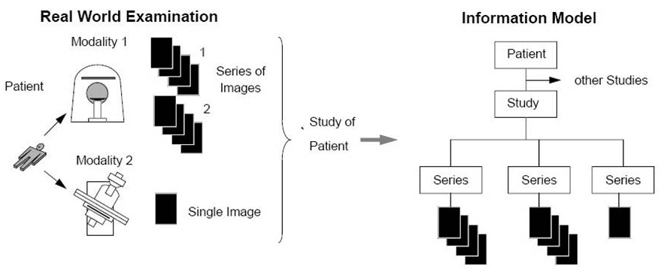

Figure 5 – Radiology to DICOM

## 2.2 ASP.NET

ASP.NET is a web application framework by Microsoft. It is built on top the Common Language Runtime, allowing .NET supported languages to be used. The main building block of ASP.NET is its web pages, officially known as Web Forms.

ASP.NET web forms contain static HTML markup, as well as markup defining server-side web controls and user controls for both static and dynamic content on the page. Static content is placed in the client facing .aspx file, while dynamic content server are placed within a <% %> block in a separate .aspx.cs (otherwise known as a code-behind file) linked that the .aspx file.

An ASP.NET project has three other file types that aid in reducing development time – the web.config, master and sitemap files. Web.config is an XML document containing the main settings and configuration file for an ASP.NET application. Specifically, the web.config file contains information that controls module loading, security configuration, session state, application language, compilation settings and database connection strings. The master file is the file from which all other .aspx files in the application derives their layout from, and the sitemap file simplifies site management by consolidating all web pages into one centralized location.

Recent versions of ASP.NET added in a Membership provider feature, and AJAX framework. Membership handles common security tasks such as logins, registration, authentication and role management, while AJAX provides asynchronous controls for the client. The RIS has AJAX Control Toolkit, a AJAX framework by Microsoft, installed for future improvements.

## C#

C# is a programming language designed for the Common Language Runtime. The most recent version, 4.0, was released on April 2010. C# is most commonly used for application and business logic in the code-behind files for the ASP web pages.

## Microsoft SQL Server 2008 R2

Microsoft SQL Server 2008 R2 is an updated release of Microsoft SQL Server 2008. The key feature of this release is a feature named FileStream, which integrates the database engine with NTFS by storing varbinary(max) binary large object (BLOB) data as files on the file system itself. There are three key reasons why FileStream is used for RIS:

1. DICOM files are on average larger than 1MB in size
2. Fast read access is considered an important requirement
3. RIS uses a middle tier for application and business logic

The major disadvantage of FileStream is its incompatibility with NHibernate, an open source object-relational mapper. As such, a significant portion of relational data persistence related programming tasks that could have been abstracted now needs to be done manually.

Like other major commercial database management systems, SQL Server has its own management software called SQL Server Management Studio. It is through this software that most of the initial interactions with SQL Server take place, before it is accessed programmatically by RIS.

## DICOM

DICOM is a standard for the creation, transmission, and storage of digital medical image and report data. It defines a data dictionary, data structures, file formats, client and server services, workflow, and compression, among other things. The most important aspects of DICOM are that it contains a file header portion, a File Meta Information portion, and a single SOP (Service-Object Pair) instance [1].

The header is made up of a 128 byte preamble, followed by the characters ‘D’, ‘I’, ‘C’, ‘M’. The preamble is usually not used, and thus contains all zeroes, although applications may use it for proprietary data [2].

After the header is the File Meta Information. This portion follows a tagged file format, and contains information about the file, the series and study it belongs to, and the patient that it belongs to [1]. This information is frequently parsed and used in the RIS itself.

The actual DICOM standard itself is very difficult to understand and use as it includes support for ACR and NEMA, two non-compatible predecessor standards. This problem is compounded by the fact that medical equipment manufacturers need not be fully compliant with the standard itself, thereby resulting in a myriad of possible data combinations.

A visual reference of a fully compliant DICOM file is provided in the following page.

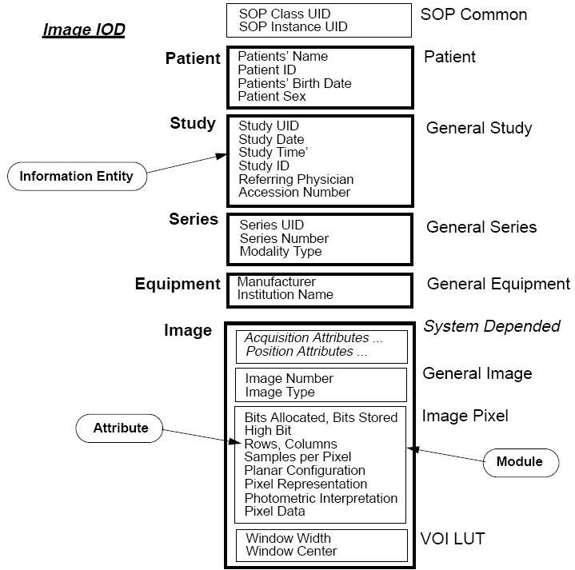

Figure 6 – Sample DICOM File

## DICOM Frameworks

Owing to its complexity, the author has spent a considerable amount of time searching for and testing out DICOM frameworks compatible with the .NET platform. The most notable frameworks currently are openDICOM and dicomSharp, both developed natively on the .NET platform, but both of which has long seen development abandoned.

However, at the time of writing the final draft of this report, no single framework has yet been found to be suitable for usage in RIS. As such, the application itself does not use any DICOM frameworks to simplify interactions with DICOM files. Instead a simple workaround, described in later chapters, is used.

The author recommends that future versions of RIS be migrated to the Java platform as development of DICOM frameworks there are much more active and maintained.

# **Database System Design**

## Overview

The RIS web application database is made up of two logically distinct collections of SQL tables. The first collection of tables is used to model domain entities in an object relational environment, and the other collection of tables is used to handle security issues common to web applications.

The latter is offloaded to ASP.NET’s Membership framework, which is automatically installed together with the .NET framework. It handles logins, registrations, authentication and role management; thereby reducing development time, and thus freeing up more time to solve problems in the business domain.

Both collections of tables are linked together with several referential integrities, and located within the same database system, so as not to make the system overly complicated. A point to take note of is that although security has been offloaded to ASP.NET, code still needs to be written to call the Membership framework functions.

Figure 5 shows an overview of all the SQL tables used in the RIS web application. For an overall view of all the tables and their relationships, please refer to the appendix.

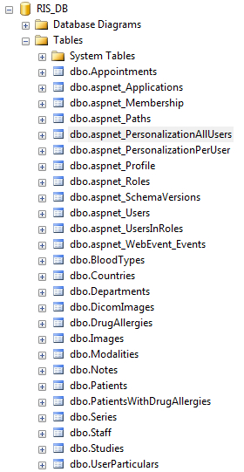

Figure 7 – All Database Tables

## ASP.NET Tables

As described in the previous section, the ASP.NET Membership framework handles user registration, login, authentication and role management features. Detailed schemas for the ASP.NET Membership tables are included below.

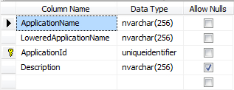

Figure 8 – aspnet_Applications

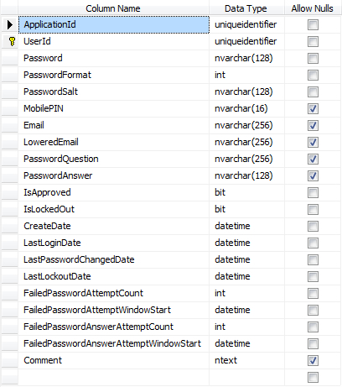

Figure 9 – aspnet_Membership

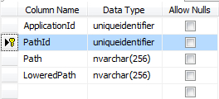

Figure 10 – aspnet_Paths

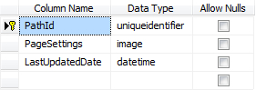

Figure 11 – aspnet_PersonalizationAllUsers

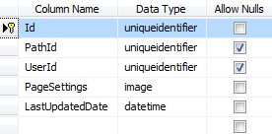

Figure 12 – aspnet_PersonalizationPerUser

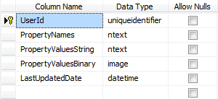

Figure 13 – aspnet_Profile

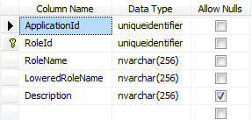

Figure 14 – aspnet_Roles

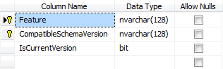

Figure 15 – aspnet_SchemaVersions

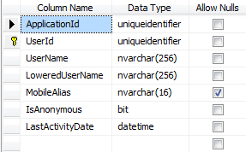

Figure 16 – aspnet_Users

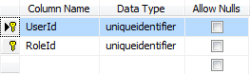

Figure 17 – aspnet_UsersInRoles

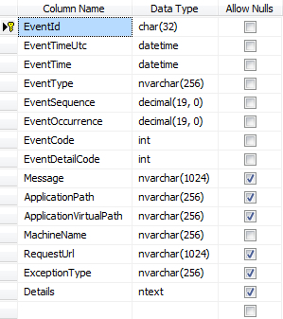

Figure 18 – aspnet_WebEvent_Events

To create the above tables in the database, we navigate to C:\%windir%\Microsoft.NET\Framework\version and run the aspnet_regsql executable tool.

Thereafter, we have to enable the Membership feature in the global web.config file by adding the following lines of code:



**Figure 19 – Membership Configuration**

## Radiology Information System (RIS) Tables

In addition to the ASP.NET default tables, the RIS web application also has its own tables that capture the domain entities of a radiology department in object relational tables as shown below. All primary key columns with integer data type are configured to be auto-incrementing identity values.

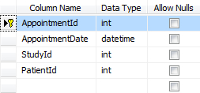

Figure 20 – Appointments

The Appointments table has:

* One-to-many relationship with Studies table
* Many-to-one relationship with Patients table

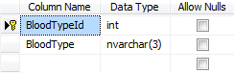

Figure 21 - BloodTypes

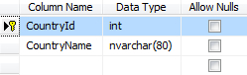

Figure 22 - Countries

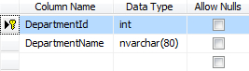

Figure 23 - Departments



Figure 24 - DicomImages

The DicomImages table uses a Globally Unique Identifier (GUID) as its data type for the primary key column. This number is automatically generated by SQL Server, and guaranteed to be a unique value based upon a time seed.

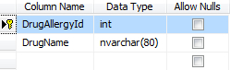

Figure 25 - DrugAllergies

The DrugAllergies table has:

* Many-to-many relationship with Patients table

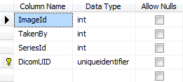

Figure 26 - Images

The Images table has:

* Many-to-one relationship with Staff table
* Many-to-one relationship with Series table
* One-to-one relationship with DicomImages table

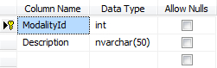

Figure 27 - Modalities

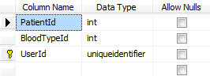

Figure 28 - Patients

The Patients table has:

* Many-to-one relationship with BloodType table
* One-to-one relationship with aspnet_Users table
* Many-to-many relationship with DrugAllergies table

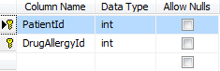

Figure 29 – PatientsWithDrugAllergies

The PatientsWithDrugAllergies is a join table between Patients and DrugAllergies.

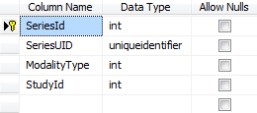

Figure 30 – Series

The Series table has:

* Many-to-one relationship with Modalities table
* Many-to-one relationship with Studies table

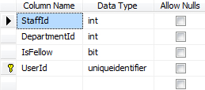

Figure 31 – Staff

The Staff table has:

* Many-to-one relationship with Department table
* One-to-one relationship with aspnet_Users table

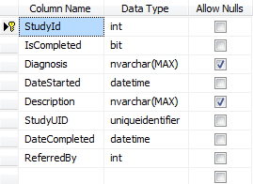

Figure 32 - Studies

The Studies table has

* Many-to-one relationship with Staff table

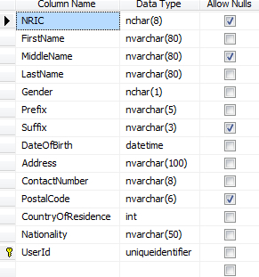

Figure 33 - UserParticulars

The UserParticulars table has:

* One-to-one relationship with aspnet_Users table

# Web Application Modules

## Overall Application Design

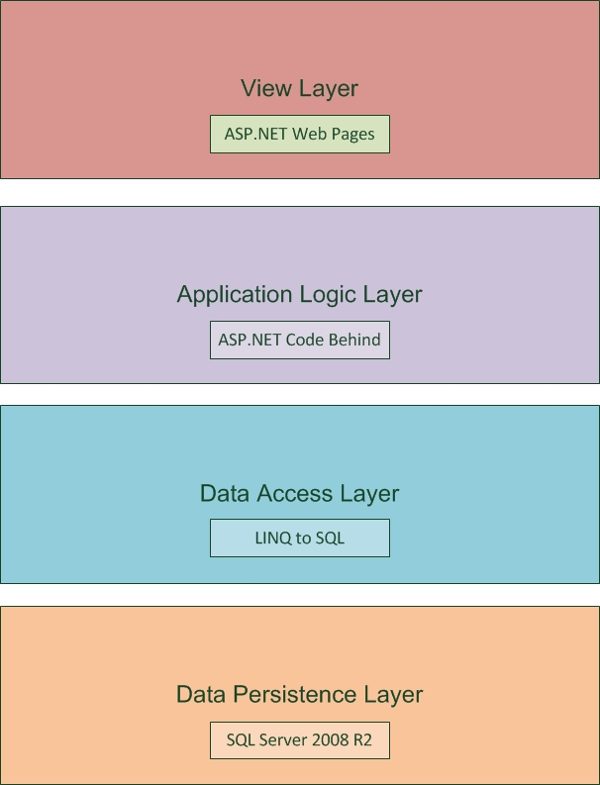

Figure 34 – Overall Design

As seen in the diagram above, the overall design of RIS is that of several distinct layers. Within each layer is the major component driving it. By adopting a layered architecture, changes made to an arbitrary layer will not adversely affect the services it offers to layers above it. In the long term, it is expected that RIS will be highly scalable due to this logical segregation. This chapter focuses on all but the data persistence layer, as it was already covered in the previous chapter.

## Data Access Layer

The data access layer is responsible for handling queries to the database. The main technology used in this layer is LINQ. Language Integrated Query (LINQ, pronounced "link") is a Microsoft .NET Framework component that adds native data querying capabilities to .NET languages. LINQ can be used with any data source and can express query behavior using a programming language, transform data query results into suitable formats, and then manipulate the results.

LINQ to SQL is an O/RM (object relational mapping) implementation that ships in the .NET Framework, and which allows a relational database to be modeled using .NET classes. It can then be queried using LINQ, as well as update/insert/delete data from it. LINQ to SQL fully supports transactions, views, and stored procedures.

To model a database using .NET classes, the tables in the database either have to be imported into Visual Studio or created from scratch. In either scenario, a DataContext class will be automatically generated. This class is the main conduit by which we query entities from the database as well as apply changes. The DataContext class created will have properties that represent each Table modeled within the database, as well as methods for each stored procedures.

RIS itself uses LINQ to SQL exclusively for data access. The figure below shows a small section of the RIS database as modeled in LINQ to SQL.

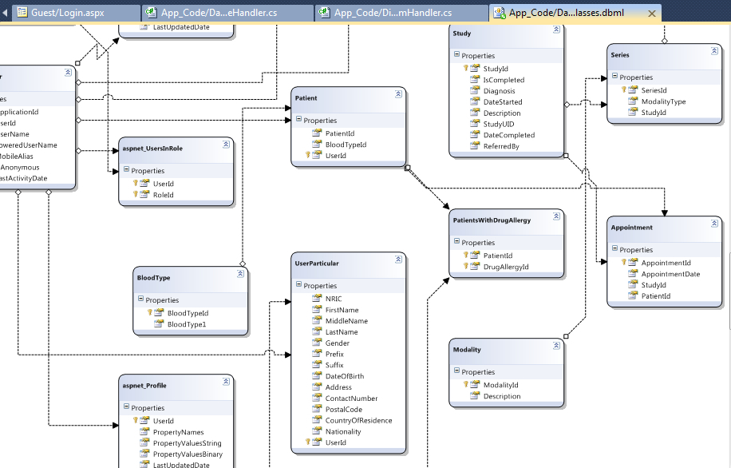

Figure 35 – Section of LINQ Classes

Notice how the modeled tables have arrows pointing to one another. The arrows represent actual relationships between the actual tables in the underlying database, namely one-to-one, one-to-many, and many-to-many.

## Application Logic Layer

The application logic layer is responsible for most of the ‘heavy lifting’ in the application. Its scope of work includes:

* Desensitizing and validating user input
* Desensitizing application output
* Appending and translating query strings
* Maintaining session state
* Ensuring user role segregation
* Providing appropriate role based services to users
* Interacting with the data access layer to query data
* Interacting with the view layer to display data

Although large in scope, we utilize as much as possible features available in ASP.NET to provide some of the low level coding needed to implement the layer’s responsibilities. For example, point 1 uses the HttpUtility class and the various ASP.NET validators in page markup to achieve the desired effect.

The main component of this layer comes from a feature of ASP.NET called Code Behind. As its name implies, Code Behind promotes the separation of code and content. That is, the user interface and the user interface programming logic need not necessarily be written in a single page. There are two ways to separate code and content:

1. By using Code-behind files that are pre-compiled modules written in any of the Microsoft .NET runtime compliant languages.
2. By developing the frequently used page logic in to separate files called Pagelets (also known as page controls) and by using them several times

The application uses the first method exclusively.

## View Layer

The view layer renders the model into a human readable form suitable for interaction. An ASP.NET page interacts with the application logic layer in order to generate an appropriate user interface, though ultimately getting its data from the data persistence layer. This layer is similar to its counterpart in the MVC design pattern, only that the overall application does not use this pattern. At present, this layer does not have full AJAX functionality.

## Physical Organization

Although this section chapter is primarily devoted to the logical design of RIS, it is only appropriate that the actual arrangement of the application files is discussed as well. The diagram below shows the file structure of RIS and goes over each important folder briefly.

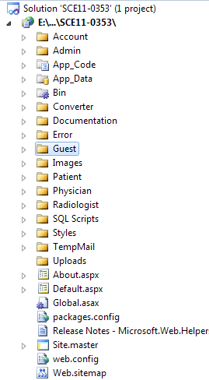

Figure 36 – Folder Layout

* Admin
  + Contains the ‘actions’ that can be performed by administrators.
* App_Code
  + Contains special executable class files needed for RIS.
* App_Data
  + Contains the actual SQL Server 2008 R2 database instance.
* Bin
  + Contains references to all external libraries and frameworks.
* Converter
  + Contains the command line utility that converts DICOM files into a binary data array for native display in web browsers. Access blocked to all users.
* Documentation
  + Contains the documentation and anything else related. Access blocked to all users.
* Error
  + Contains the custom error page that is to be displayed to remote users.
* Guest
  + Contains the ‘actions’ that anonymous users can perform.
* Images
  + Contains images that are used to make the pages more attractive.
* Patient
  + Contains the ‘actions’ that patients can perform.
* Physician
  + Contains the ‘actions’ that physicians can perform.
* Radiologist
  + Contains the ‘actions’ that radiologists can perform.
* SQL Scripts
  + Contains some executable SQL scripts for populating the database. Access blocked to all users.
* Styles
  + Contains the CSS style sheets for RIS.
* TempMail
  + Meant as a temporary email drop-off folder during development. Access blocked to all users.
* Uploads
  + Meant as a temporary drop-off folder for uploaded DICOM files

The reason for organizing the files in the application is twofold. The first is for easier site management as the numbers of pages grow. The second is for easier migration to ASP.NET MVC in future.

# Experimental Systems and Results

## All Users

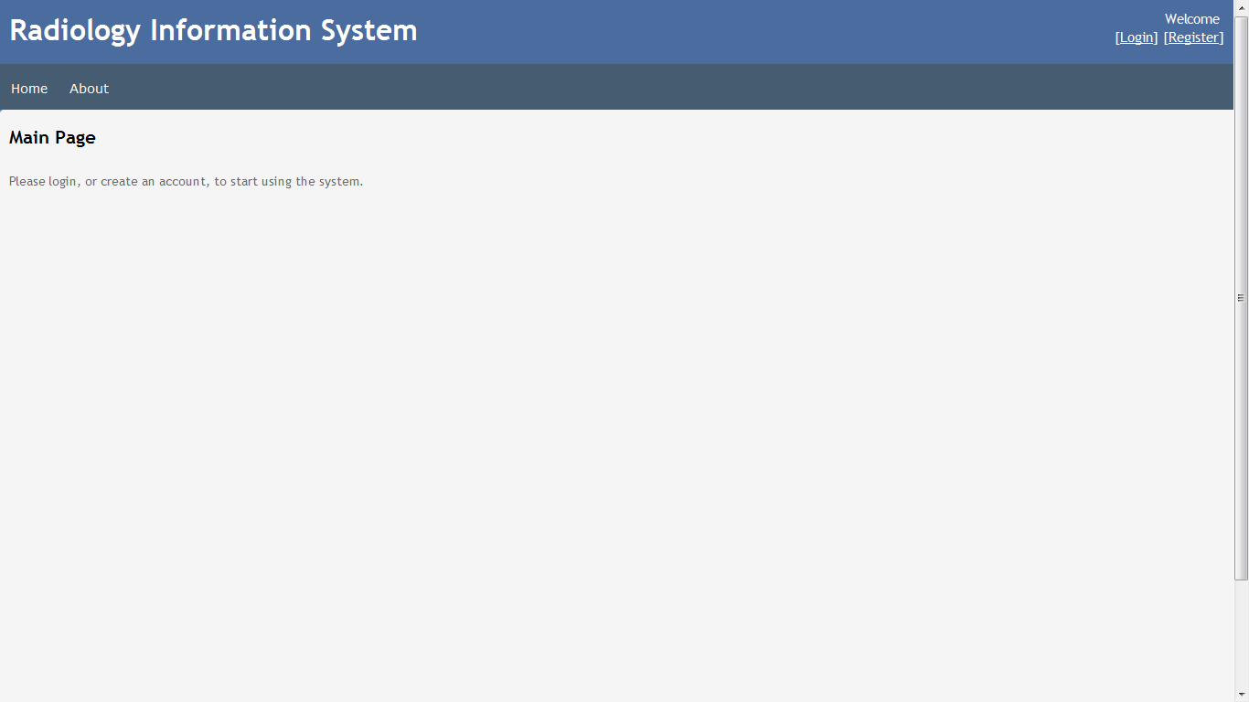

Figure 37 – Main Page

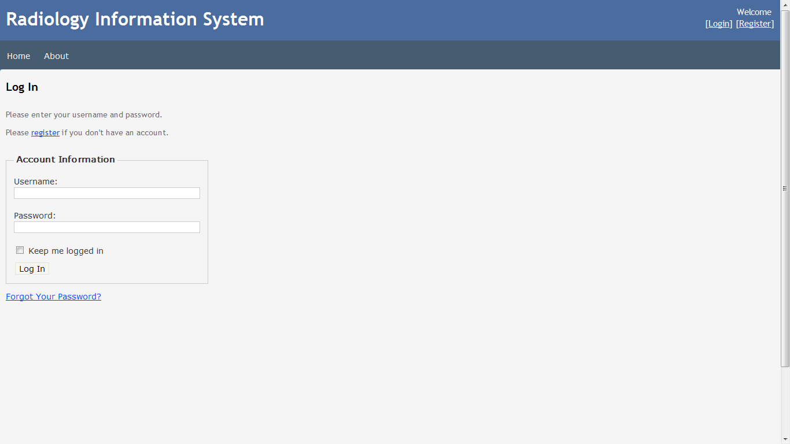

Figure 38 – Log In

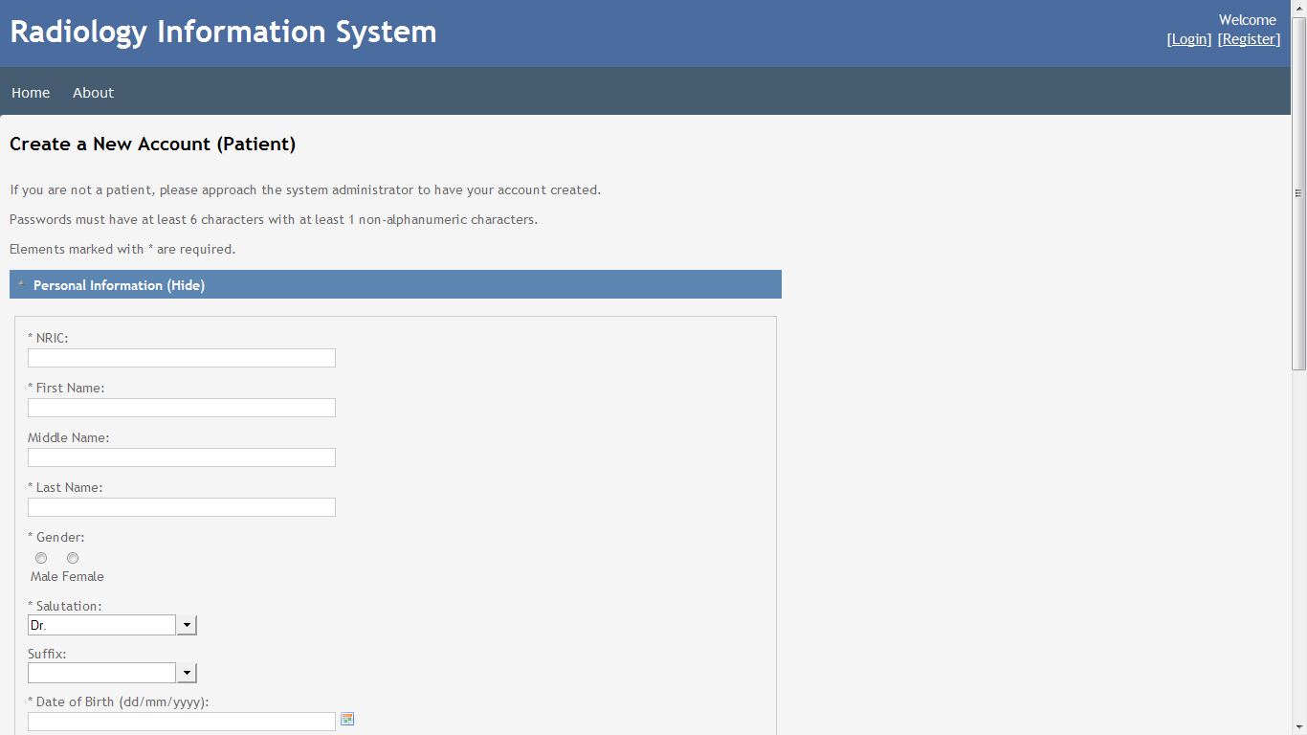

Figure 39 – Create New Account (Patient)

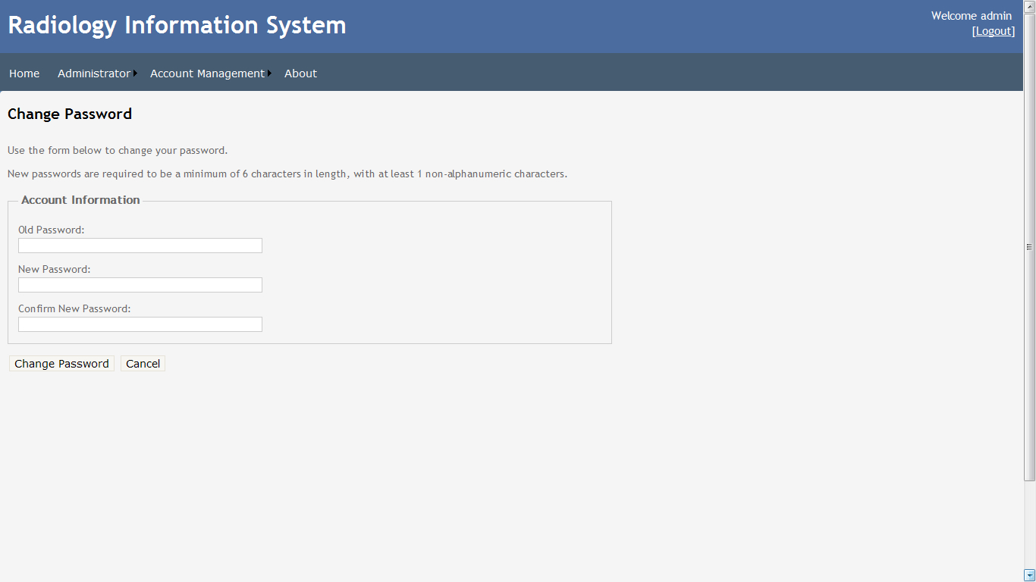

Figure 40 – Change Password

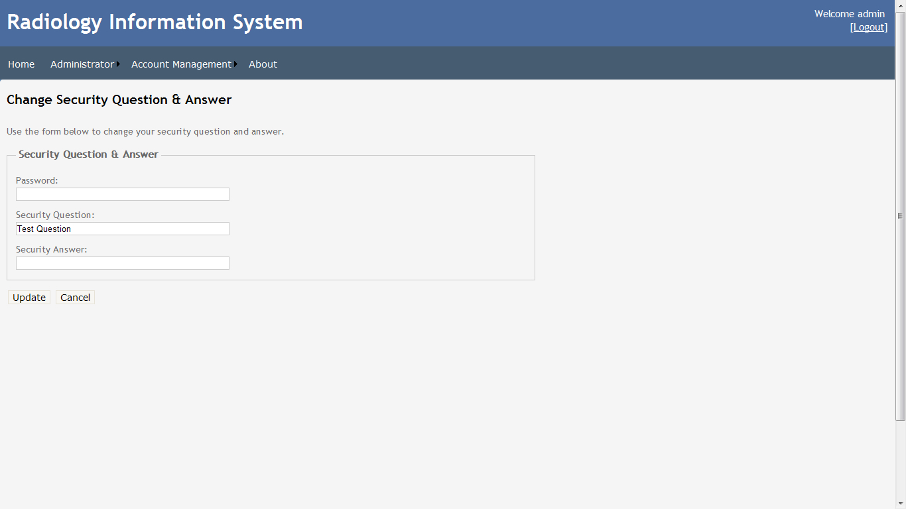

Figure 41 – Change Reset Question

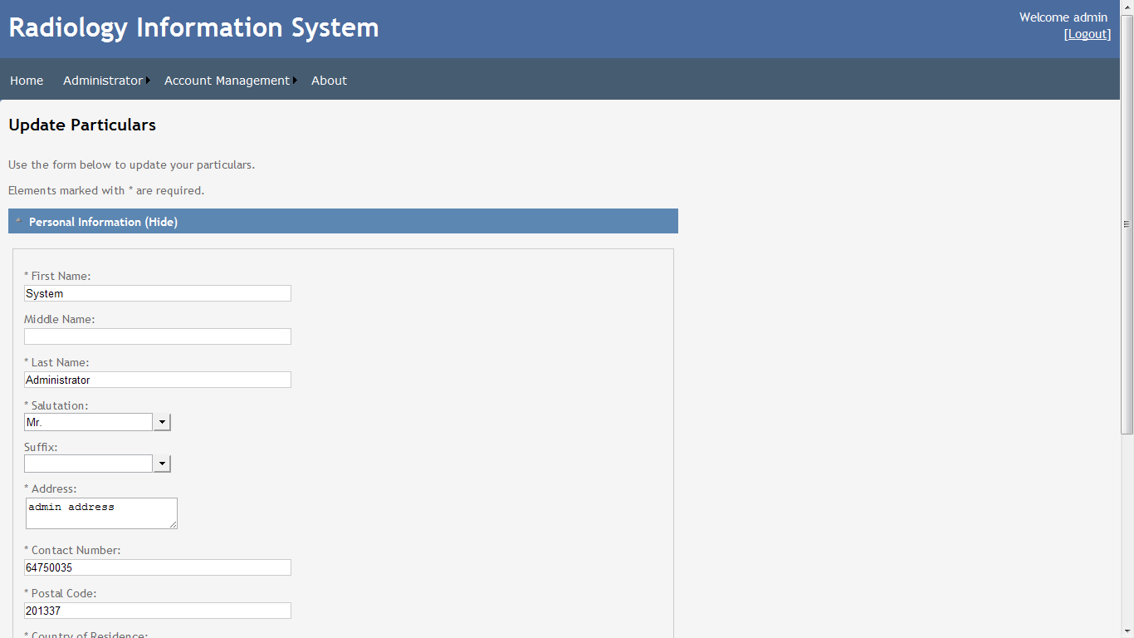

Figure 42 – Update Particulars

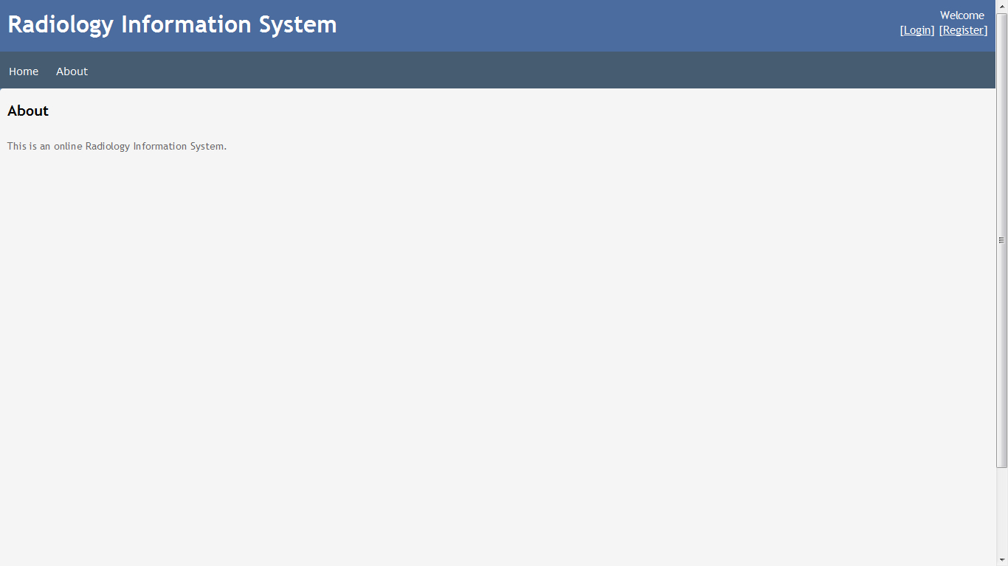

Figure 43 – About

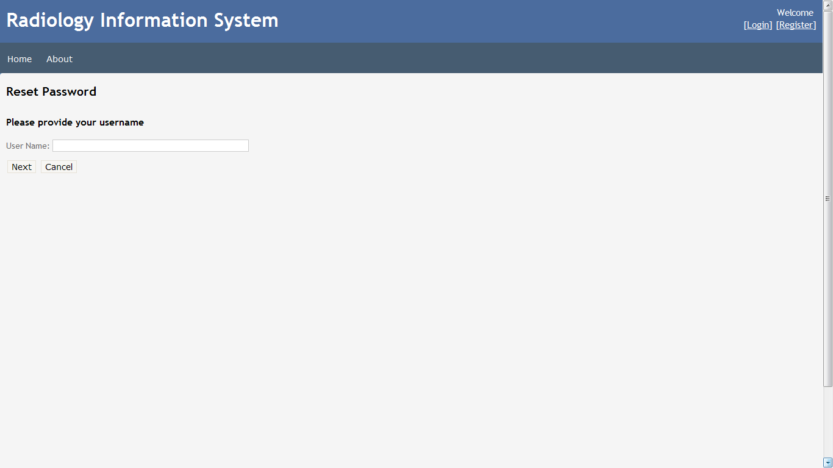

Figure 44 – Reset Password

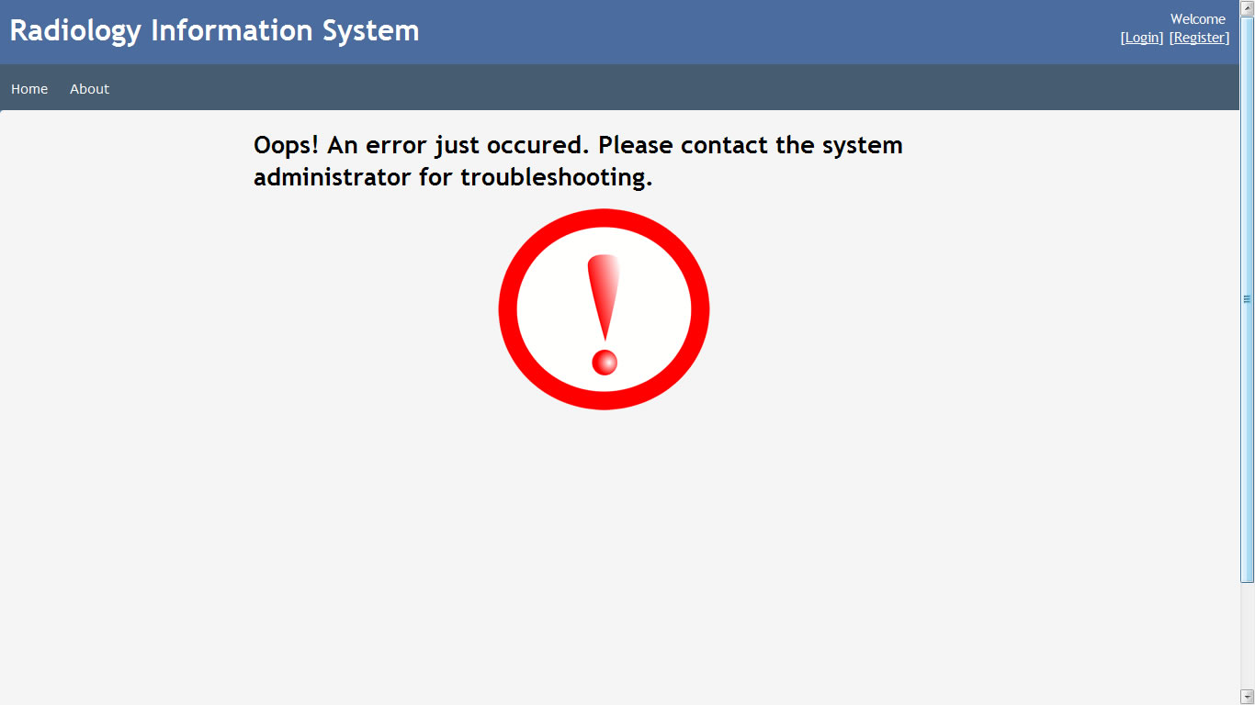

Figure 45 – Error

## Admin

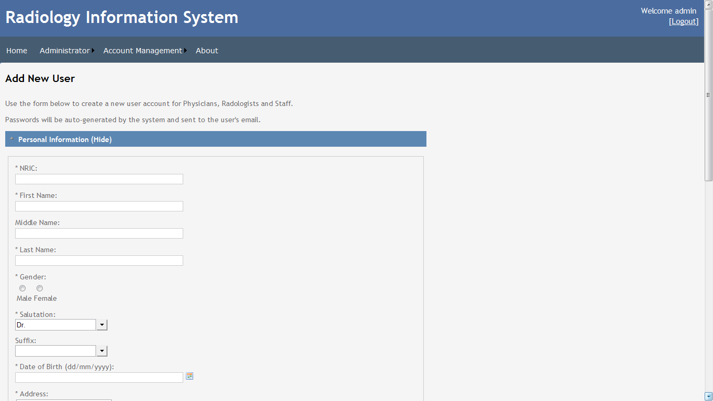

Figure 46 – Add User

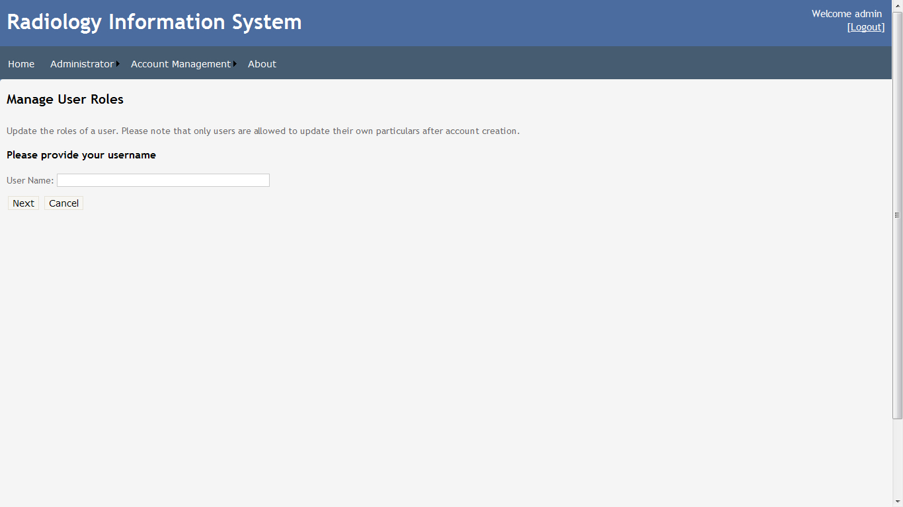

Figure 47 – Manage User Roles

## Physician

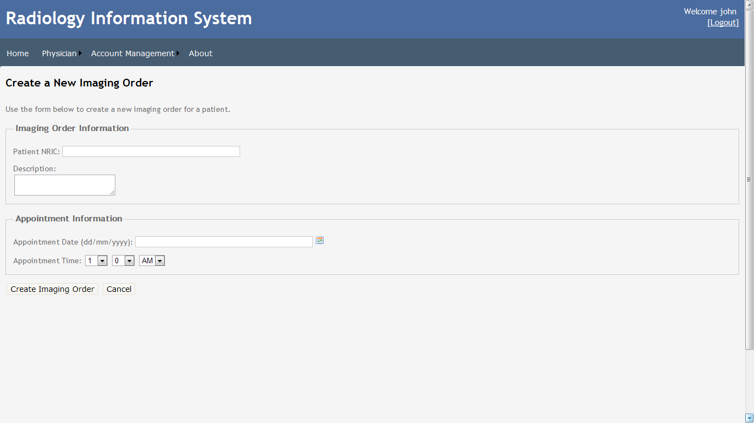

Figure 48 – New Imaging Order

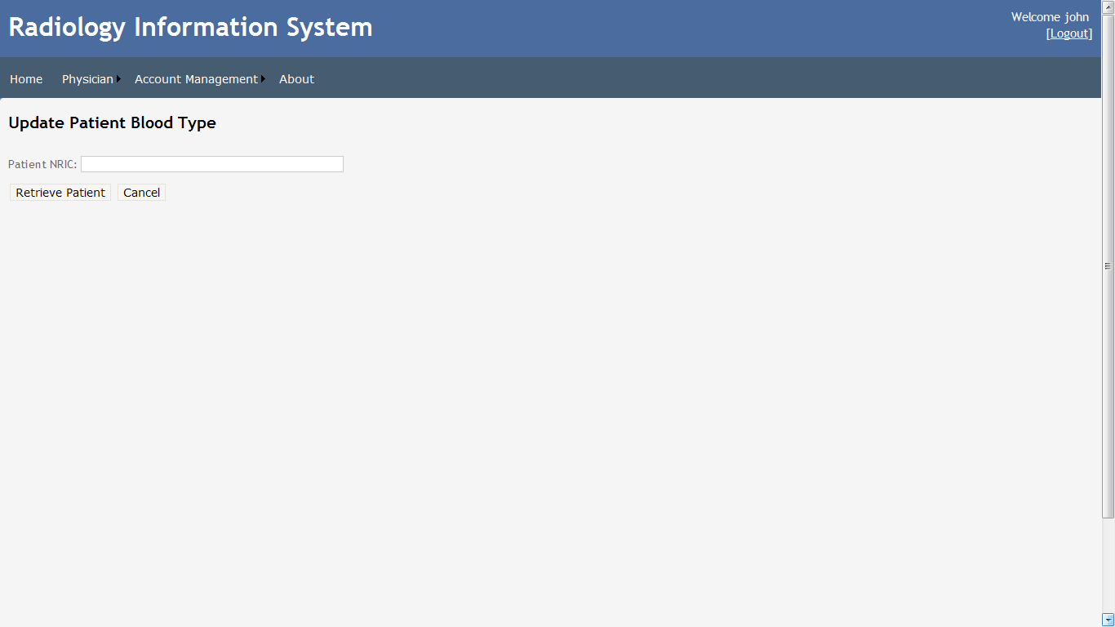

Figure 49 – Update Patient Blood Type

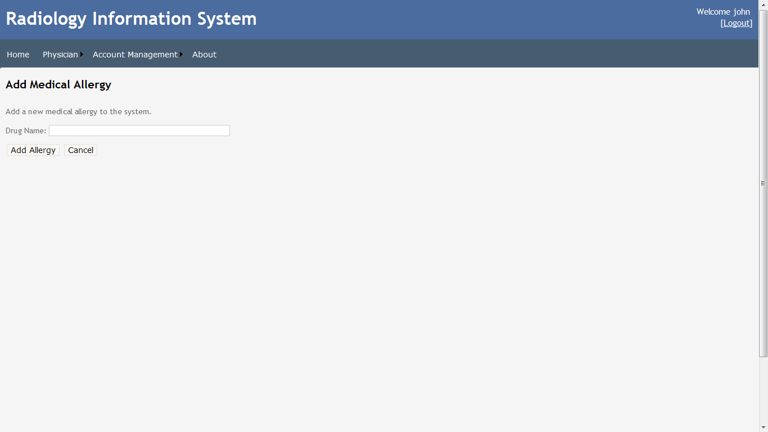

Figure 50 – Add Medical Allergy

## Radiologist

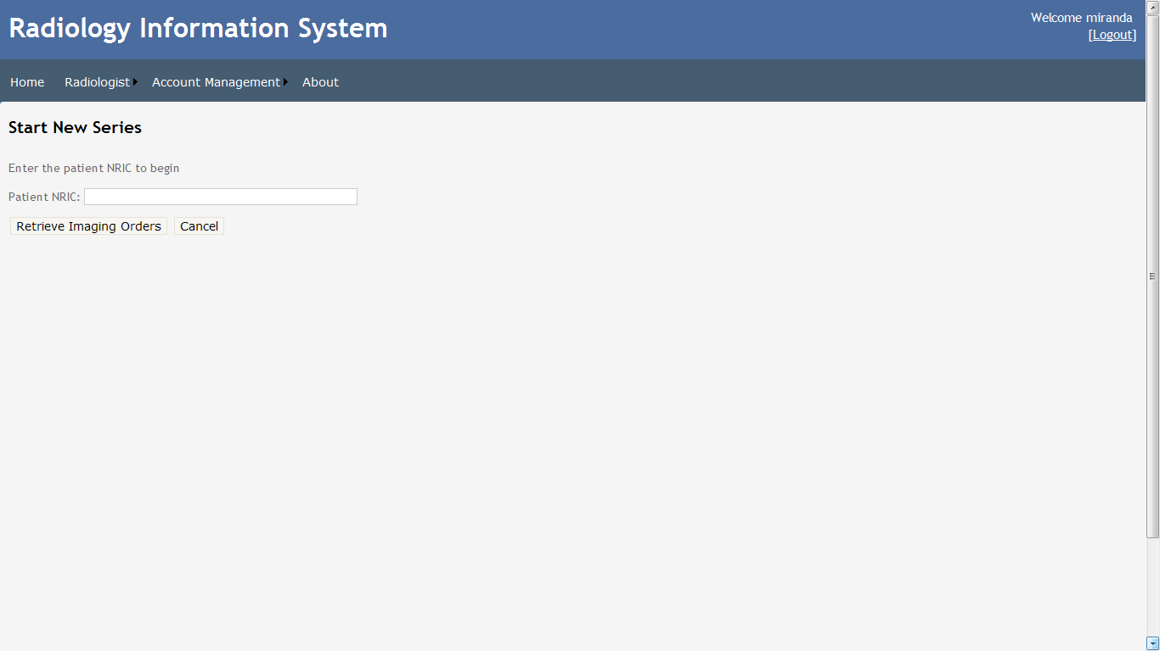

Figure 51 – Start New Series

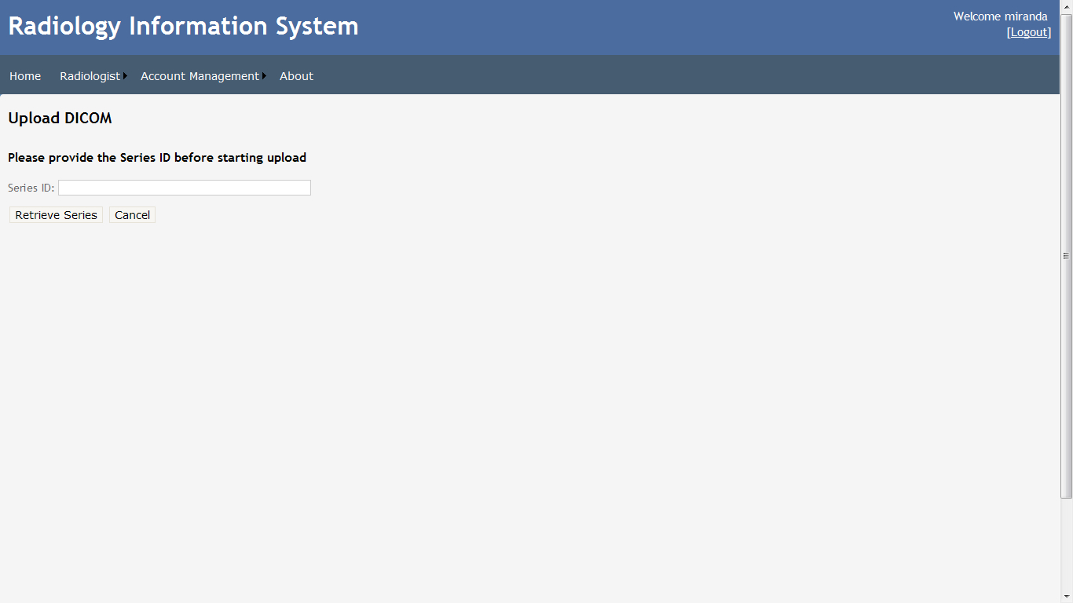

Figure 52 – Upload DICOM

# Discussion and Conclusion

## Summary

This report covered several topics at length. First, it provided background information on telemedicine and the inspiration for developing a web based Radiology Information System (RIS). Second, the author presented his research findings on the software tools, standards and potential frameworks that will be utilized by the application. The architectural design of the application was then presented before drilling into the specifics.

As the application was being developed, the complexity of the DICOM standard persisted as a problem, eventually forcing the author to convert DICOM files uploaded to the system in order to circumvent it.

## Discussion

RIS, like most web applications, does not require any complex "roll out" procedure to deploy; a compatible web browser is all that is needed. The low barrier to entry will not doubt help to drive adoption rates, further increasing usage of telemedicine in Singapore as a whole.

## Future Work

Like every software endeavor, there are several ways in which RIS can be improved on.

The first way is to incorporate AJAX functionality into more pages. AJAX is a development technique used on the client-side to offer a highly interactive user interface whose responsiveness rivals that of desktop applications. This also helps to cut down on the amount of data that needs to be exchanged between the client and server as only a minimum amount of data is used.

The second way is to migrate it to an ASP.NET MVC 3 Web Application project. Based on ASP.NET, the migration will allow us to redesign RIS as a composition of three roles: Model, View and Controller. The other big reason for doing so is that a new HTML helper, WebImage, would be available for use. This greatly simplifies the need to parse byte data arrays into the Response object in order to send imaging data to the client.

The final way is to utilize caching. Instead of having to query the database everytime a page is requested or posted back, the server can cache commonly accessed data to reduce processing times. This will be especially useful if image data is cached, as it is not expected to change once created.

# References

|  |  |
| --- | --- |
| [1] | D. Evans, “A Very Basic DICOM Introduction,” dcm4che.org, 21 August 2006. [Online]. Available: http://www.dcm4che.org/confluence/display/d2/A+Very+Basic+DICOM+Introduction. [Accessed 16 October 2011]. |
| [2] | C. Rorden, "The DICOM Standard," [Online]. Available: http://www.cabiatl.com/mricro/dicom/index.html. [Accessed 10 December 2011]. |

# Appendix

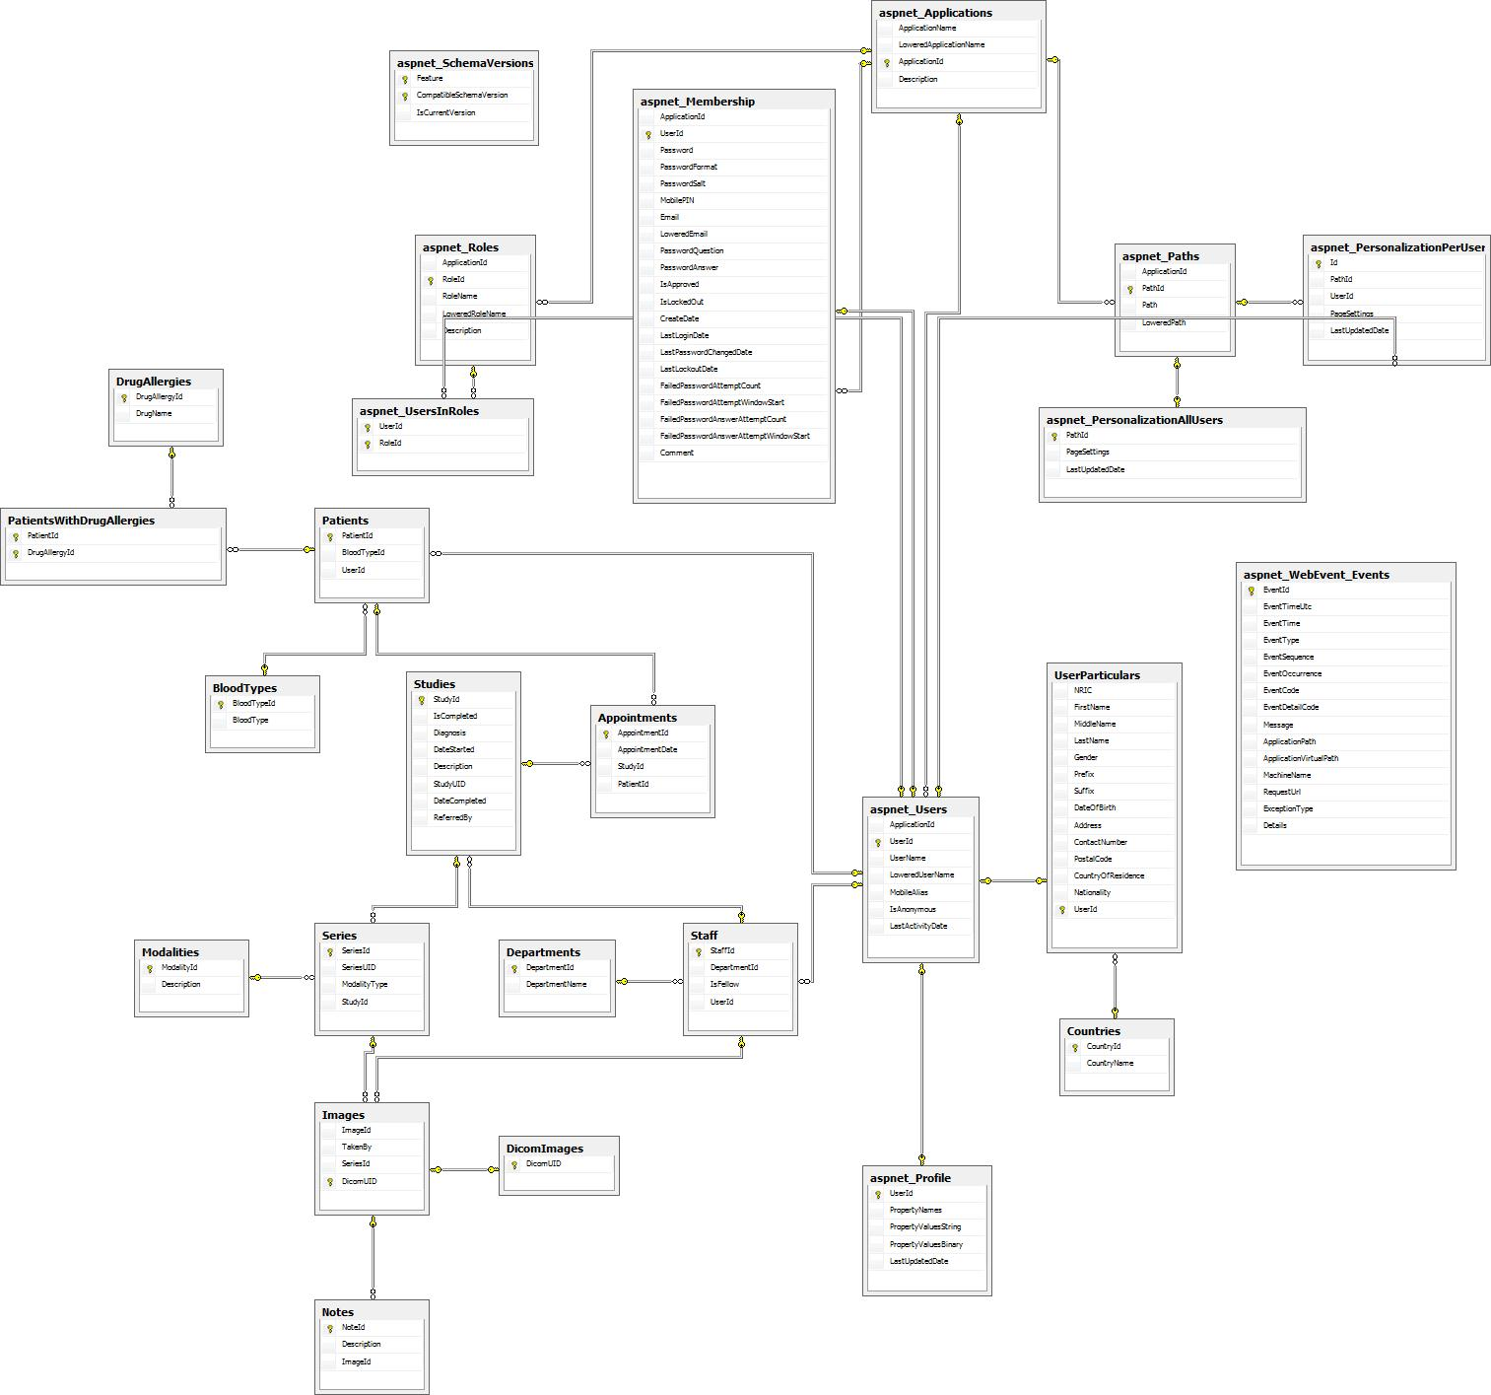

Figure 53 - Database Schema